Parent/Guardian Contact Information (PLEASE PRINT)

First ______________________________________________ Last:_________________________________________
Street Address:_______________________________________ City:____________ State:_________ Zip:__________
Home#:_________________________ Work #:_________________________Cell #:____________________________
Email:___________________________________________________________________________________________

Child(ren) Information

First:____________________________________ Middle:____________ Last :________________________________
Please Circle: Male Female Age______ DOB_________ Child’s Phone #:____________________________
Street Address:_______________________________________ City:____________ State:_________ Zip:___________
School Name_________________________________________ Current Grade ______ Next School Year Grade______
Please provide child’s t-shirt (NOTE: T-shirt are in adult sizing): CHECK MARK
X-SMALL____SMALL_____MEDIUM_____LARGE_____ XL____XXL_____

First:____________________________________ Middle:____________ Last :________________________________
Please Circle: Male Female Age______ DOB_________ Child’s Phone #:____________________________
Street Address:_______________________________________ City:____________ State:_________ Zip:___________
School Name_________________________________________ Current Grade ______ Next School Year Grade______
Please provide child’s t-shirt (NOTE: T-shirt are in adult sizing): CHECK MARK
X-SMALL____SMALL_____MEDIUM_____LARGE_____ XL____XXL_____

First:____________________________________ Middle:____________ Last :________________________________
Please Circle: Male Female Age______ DOB_________ Child’s Phone #:____________________________
Street Address:_______________________________________ City:____________ State:_________ Zip:___________
School Name_________________________________________ Current Grade ______ Next School Year Grade______
Please provide child’s t-shirt (NOTE: T-shirt are in adult sizing): CHECK MARK
X-SMALL____SMALL_____MEDIUM_____LARGE_____ XL____XXL_____

First:____________________________________ Middle:____________ Last :________________________________
Please Circle: Male Female Age______ DOB_________ Child’s Phone #:____________________________
Street Address:_______________________________________ City:____________ State:_________ Zip:___________
School Name_________________________________________ Current Grade ______ Next School Year Grade______
Please provide child’s t-shirt (NOTE: T-shirt are in adult sizing): CHECK MARK
X-SMALL____SMALL_____MEDIUM_____LARGE_____ XL____XXL_____
Emergency Contact Information

 | First & Last Name | Phone Number | Relationship to Child
Contact #1
Contact #2
Contact #3
Does your child(ren) have any known allergies (ex. Pollen, Tree/Nuts, Medication, Latex etc.)? DO NOT LEAVE BLANK.
NOTE: If your child requires any medication during camp, an Administration of Medication must be filled out.
YES____ NO_____ If yes, please specify for each child below:
Child’s Name:________________________________ Allergy/Allergies:______________________________________
Symptoms: __________________________________ Medication for allergy/allergies: _________________________
YES____ NO_____ If yes, please specify for each child below:
Child’s Name:________________________________ Allergy/Allergies:______________________________________
Symptoms: __________________________________ Medication for allergy/allergies: _________________________
YES____ NO_____ If yes, please specify for each child below:
Child’s Name:________________________________ Allergy/Allergies:______________________________________
Symptoms: __________________________________ Medication for allergy/allergies: _________________________
YES____ NO_____ If yes, please specify for each child below:
Child’s Name:________________________________ Allergy/Allergies:______________________________________
Symptoms: __________________________________ Medication for allergy/allergies: _________________________

Does your child(ren) suffer from any medical condition (diabetes, asthma etc.) or/and disabilities?
YES____ NO____ If yes, please provide all necessary details for each child:
CHILD’S NAME CONDITION(S) MEDICATION(S) or ASSISTANCE (If required)
___________________ ______________________________________ __________________________________
___________________ ______________________________________ __________________________________
___________________ ______________________________________ __________________________________
___________________ ______________________________________ __________________________________
Waivers (Please check all that applies)
Liability Waiver for Camper
- I hereby voluntarily release, forever discharge, and agree to indemnify and hold harmless One Village Alliance, (O.V.A) its directors, affiliates, sponsors, managers, and all team members/staff from any and all claims, demands, or cause of action, which are in any way connected with participation in activities sponsored by O.V.A, while using equipment or facilities, including such claims which alleged negligent acts or omissions of OVA, its directors, organizers, sponsors, managers, or any other appointed team members.
- I certify that my child(ren) has adequate insurance to cover any injury or damage he/she may cause or suffer while participating, or I agree to bear the costs of such injury or damage myself. I further certify that my child(ren) have no medical or physical conditions which would interfere with their safety in OVA activities, or I am willing to assume, and bear the cost of all risks that may be created, directly or indirectly, by any such condition.
Photography Waiver
- I hereby authorize One Village Alliance, (OVA) to use and reproduce any photographs, personal narrative, interviews, or audio and video recording of my child(ren) participation in OVA activities for educational purposes. I permit OVA to use images of my child as a program participant in internal and external promotional material. This includes any printed material, broadcast, print advertising, promotional videos, website, broadcast, and print media news coverage.
Permissions/Release
- I permit my child(ren) to participate in activities that One Village Alliance conducts outside the One Village Alliance facilities.
- I understand that One Village Alliance is not responsible for any personal items, lost or stolen, at our programs.
- Once my child has signed in and entered OVA, I understand that there will be no running in and out of the building. At the end of the program, children will be released and are no longer under One Village Alliance’s supervision.
- I hereby grant my child/children permission to be released from program premises promptly at scheduled program end time at 3:30pm. I take full responsibility to pay the $5 per minute late fee per the following release instructions for my child(ren).
- I have signed and verified my Pick-up/Drop form for my child(ren) in the AWTS package provided. My Child(ren) is/are permitted to be released without supervision (if is deemed a walker or bike rider) or picked up by parent/guardian or authorized guardian promptly at dismissal.
- I have carefully read and fully understand, and agree to the policies stated above.
- I have carefully filled out this form to its entirety. I agree and understand that if this form is not completed in its entirety there will be a delay in processing my child for children registration.
DATE:_______________________
PARENT/GUARDIAN PRINT NAME: __________________________________________________________________
PARENT/GUARDIAN’S SIGNATURE: __________________________________________________________________
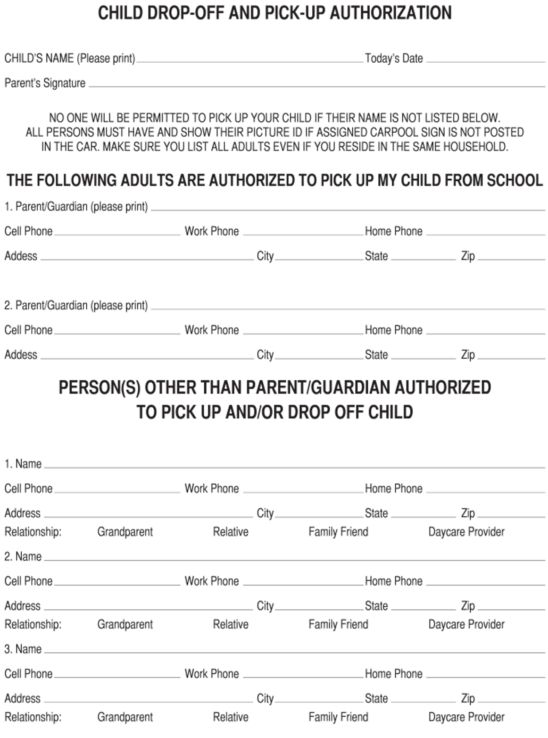
Drop off/ Pick up Authorization Form

